Shared Church Garden and grass rota 2018
Weeks commencing (Mondays)
May 1 7 14 21 28
June 4 11 19 26
July 2 9 16 23 30
August 6 13 20 27
Sept 3 10 17 24
Oct 1 8 15
William Patrick Alan Dennis Mike/Matthew
07907249537624677 624833 622162 389796 /624474
Up-keep
I have tried to get the path grass and the graveyard garden up to date so far this year. I have done three mowings and will do another this week, and complete the weeding. Later I will lift the bulbs and put in bedding plants. I have sprayed the edges of the path grass and the gravel in the graveyard to keep down the weeds.
As last year, if we take a week each then it shares the load. I suggest the weeks go from Monday to Sunday, so that the grass is cut, and the garden weeded each week ready for Sunday. Some weeks, if it is dry, will mean some watering during the week as well (that is when we have the bedding plants in). Please do any weeding that is necessary.
Grass cuttings are best put in a plastic sack and taken to the tip. Sacks in the shed.
If the week for your turn is not convenient please arrange a swap, or contact Peter ( I am reserve / emergency )
Safety issues / precautions
The steps to the shed can be slippery if wet .
Use the wooden planks to wheel out the mower, do not lift it.
Wear leather shoes, with steel toe-caps if possible. Do not wear sandals.
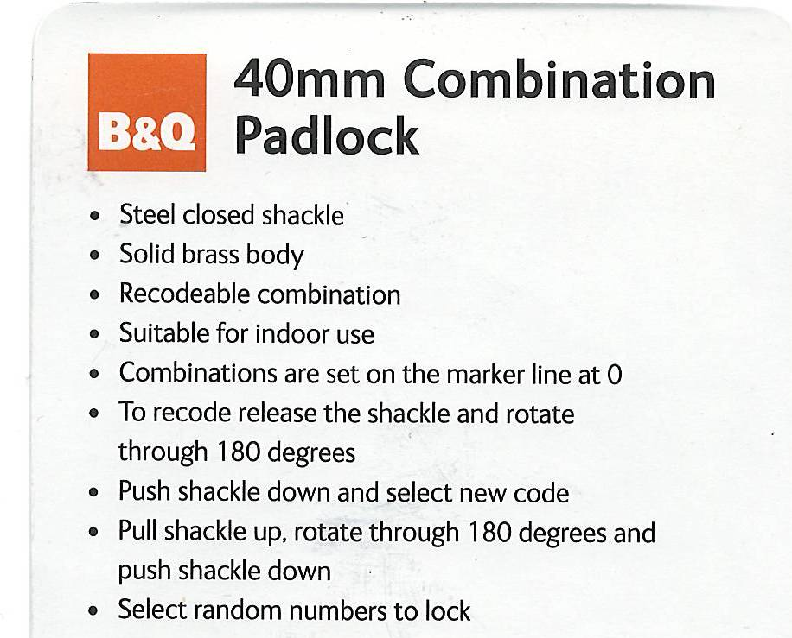
Ear muffs and goggles are available in the shed.

Three or four presses of the primer and the mower should start first pull.
If you purchase more petrol, please dose with the additive which is kept in the shed. This keeps the carburettor clean .
The combination lock on the shed. It is set at 808.
Hopefully we will get a new shed soon ! ! !

